# Silicon Valley Participation in the Defense Industrial Base

Given the emphasis on information and robotics technology, it should come as little surprise that Silicon Valley is a key player in the Third Offset strategy discussed in section X.X. Sec. Carter (2015) unveiled part of that strategy during his Drell Lecture at Stanford University. During that speech he noted a "long history of partnership" but also detailed recent strains:

"At times, we also eyed each other warily – like when Bobby Inman faced off against Martin Hellman and Whit Diffie over public-key encryption and commercialization; or during the controversy over the Clipper [chip] in the 1990s; and, more recently, after the actions of Edward Snowden" (para 15).

One reason that Sec. Carter puts such emphasis on the need to "renew the bonds of trust and rebuild the bridge bridge between the Pentagon and Silicon Valley" (para 16) is simply that it's where many of the high technology companies are located. The Valley's top firm, Apple Computer, has XX billion in cash on hand, greater than the total market valuation of the top five Defense Firms.[1] However, Sec. Carter also made reference to the economic importance of geography when describing why Silicon Valley is not just a shorthand for the location of the headquarters of a range of prominent vendors:

"The reason that Silicon Valley is so successful is that it has the right people in it but there’s proximity as well – there’s an ecosystem out here.  Everyone’s in the same general area, which not only helps forge relationships, but also helps spread new ideas.  And that geographic proximity, coupled with strong links between academia and industry, has made this entire region a nexus for innovation" (para 43).

While Sec. Carter's established the importance of DoD-Silicon Valley partnerships and cited a variety of success stories, but he did not provide overall metrics as to the state of the relationship. As Figure 1 below shows, prime contract obligations top Silicon Valley vendors total less than 3 billion a year, never amounting to more than 1 percent of DoD contract spending. There was a large and sustained increase starting in 2009, driven by Hewlett Packard's acquisition of Electronic Data Systems which had a been a significant defense contractor.[2]

Beneath the top-line trends, three points stand out about the relationship between the DoD and major Silicon Valley vendors: the narrowness of the base, the persistence of the top tier but tumult beneath that, and the avoidance of cuts due to drawdown or the budget caps thanks to Hewlett Packard.

Figure 0‑1 Defense Contract Obligations to Major Silicon Valley Vendors, 1990-2014

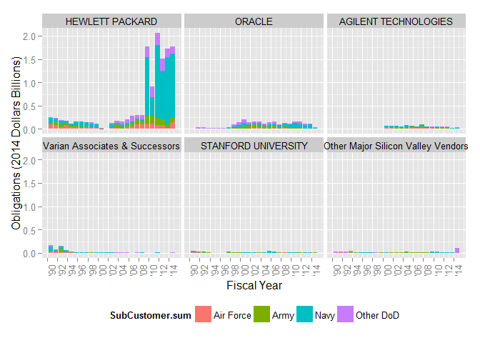

### Narrow Silicon Valley Base

Figure 1 shows the contract obligations going to thirty-plus vendors on this paper's Silicon Valley Index. That index is made up of Stanford University, publicly traded companies that made it into the top 30 Silicon Valley between 2013 and 2015.[3] Of those thirty plus major vendors only five had a quarter billion of more in total obligations since 1990. Hewlett Packard’s dominance is further emphasized by the fact that the number three company, Agilent Technologies, spun off from Hewlett Packard in November of 1999. The approximately hundred million dollar spike in other major Silicon Valley vendors in 2014 was driven by Cisco Systems, which if sustained could quickly allow that company to join the ranks of Oracle and Agilent Technologies.

Unsurprisingly, Silicon Valley contractors are overwhelmingly focused in Electronics and Communications systems (86 percent of obligations). The secondary category is other R&D and knowledge-based services (5 percent of obligations), which are the predominant service provided by Stanford University throughout the study period and the other major Silicon Valley vendors in the first half of the nineties. Hewlett Packard had a significant presences in the facilities and construction and missiles and space systems space that was largely inherited by Agilent Technologies after the spinoff. Facilities and construction services includes management of research facilities, and so still remains in the high technology domain and across all vendors accounts for just under 5 percent of obligations.

### Persistence in the Top Tier, Tumult Below

Another noteworthy trend is that while companies do slowly rise and fall, there is significant stability within the top companies. Aggregated across the study period, the top five vendor families accounted for more than 97 percent of total obligations. For the remaining major Silicon Valley vendors had obligations of barely over half a billion dollars over twenty five years. Status as a notable DoD partner does not guarantee future business. Varian Associates obligations did begin to drop off the charts even before the company split into three parts in 1999.[4] Nonetheless, this consistency is remarkable given the dynamism and turnover in the technology sector during this period. Figure 1 provides one clue as to the resilience of these specific vendors, each of them is consistently selling to multiple parts of DoD, a trait that appears to be necessary, but not sufficient, for staying in the top tier.

This finding can illuminate the question of why Silicon Valley companies do not do more business with the Department of Defense. Loren Thompson (“Five Reasons Why Silicon Valley Won’t Partner With The Pentagon - Forbes,” n.d.) argues that efforts by DoD to bring in contracting with the government is not appealing to Silicon Valley due because they have a range of downsides while providing low profits. Thomson and Sec. Carter both identify fear of DoD policies regarding intellectual property as an important issue, though Sec. Carter emphasized that “[w]e need the creativity and innovation that comes from start-ups and small businesses, and we know that part of doing business with them involves protecting their intellectual property” (para 48). Thompson’s broader critique, which is applicable to the commercial sector as a whole, does fit with the narrowness of the base. It also may help explain why vendors like Intel, Network Appliance, VMWare , Symantec, and Synex all were obligated at least ten million dollars over the study period but never became consistent DoD contractors.

Other coverage of Silicon Valley leaders and analysts echo the distrust mentioned by Sec. Carter and the broader concerns about the procurement system with a particular emphasis on the pace of operations. Art Gilliland, a CEO with a cyber security firm said that his sector “often would like to work with the government, if not for the often intensely bureaucratic and expensive process it entails. Often, he says, selling into the government requires certifications that cost companies upwards of $100,000, and can take more than a year to receive” (Markowitz, 2015). This specific complaint highlights the issue of barriers to entry. For well capitalized vendors, $100,000 may be a drop in the bucket, but time is a precious commodity.

Based on the major vendors included in this study, it appears that the those vendors that can at times breach $30 to $50 million in annual obligations have overcome the procedural and cultural barriers of working with DoD. There's no theoretical or regulatory logic to that particular cutoff, however, it does serve as a warning that smaller successes in Silicon Valley-DoD match-making will not necessarily blossom into longstanding partnerships. This pattern will be put to the test when complete obligation data is released for fiscal year 2015. In 2014, Cisco Systems burst onto the scene with nearly one hundred million in obligations. If this high barrier to entry is indeed one of the main constraints on Silicon Valley vending, than that company would qualify as a top tier DoD Silicon Valley vendor in 2015 as well.

### Silicon Valley Avoided Drawn down and Budget Cap Cuts, Thanks to Hewlett Packard

However, in aggregate the partnership grown during the drawdown. Average spending from 2010-2012 was over 37 percent higher than the 2008-2009 levels when the DoD budget was at its apex. Even during the BCA years of 2013-2014, spending was another 12 percent higher. However, a single vendor, Hewlett Packard, accounts for more than seventy percent of all obligations during the study period and is disproportionately responsible for this growth. When looking at all other vendors, the 2010-2012 period was 7 percent higher than 2008-2009 levels, but average obligations were nearly 20 percent lower in the 2013-2014 period than during the early years of the drawdown.

Figure ‑ DoD Obligations to Major Silicon Valley Vendors by Defense Component

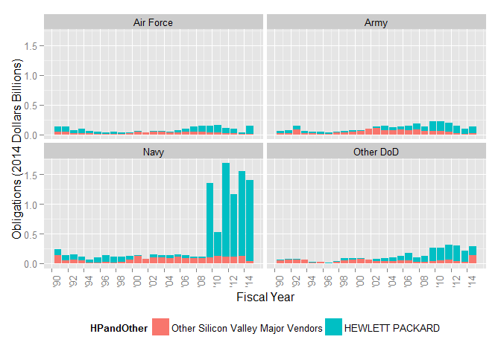

When examining the trends by Defense component, as shown in Figure 0‑2, the trends are likewise not evenly distributed. Both Navy and Other DoD had average obligations in 2010-2012 that were nearly twice their 2008-2009 levels. The Army experienced a small increase (5 percent) while the Air Force suffered average levels shrunk by 16 percent. Under the budget caps, Navy continued to grow with a nearly 32 percent rise while all other components declined, with Other DoD experiencing the smallest decline at 13.4 percent.

Sec. Carter’s speech did not mention Hewlett Packard by name during his speech and much of his agenda is focused on smaller vendors and startups. However, when it comes to the traditional acquisition system, the newly minted Hewlett-Packard Enterprise is likely to remain a predominant player. Similarly, the Navy’s 3.5 billion dollar Next Generation Enterprise System (NGEN) is a bellwether for the DoD-Silicon Valley partnership, even though it is a more traditional information technology system rather than the cyberwarfare or robotics systems Sec. Carter focused on.

NGEN program is the successor to the Navy Marine Corps Intranet (NMCI), “the Department of the Navy’s (DON) shore-based enterprise network in the continental United States and Hawaii... NMCI represents about 70 percent of all DON IT operations and is second only to the Internet in size" (“About NMCI,” n.d., para. 1). Critics of the contract lambasted the approach which leased hardware and software to the government, relied on the contractor for upgrades, and included metrics lagged behind hardware advances in the commercial sector. Hewlett Packard took over the NMCI when it acquired Texas-based Electronic Data Systems and cited high customer satisfaction rates by the end of contract. (“HP Holds Navy Network ‘Hostage’ for $3.3 Billion | WIRED,” n.d.). Hewlett Packard was part of a team that won the lowest price-technically acceptable competition to become the prime contractor for NGEN which transitions ownership of the network back to the government (“Navy, HP tout NGEN as a model for IT services -- FCW,” n.d.). The NGEN will be recompeted in 2018, which may prove an inflection point for the largest Silicon Valley Defense contractor (“Navy gearing up for NGEN recompete -- Washington Technology,” n.d.).

### Implications for the Future

The contracting data illuminates the challenges that DoD will have to overcome to achieve closer partnership with Silicon Valley. The present base is dominated by a small number of vendors and new entrants that do not win more than $30 to $50 million in annual obligations have historically sought greener pastures rather than slowly building to greater participation. That high threshold is worrisome when headline making companies like Google-acquired robotics maker Boston Dynamics’s big breakthrough contract was for 10.8 million (“Google Adds to Its Menagerie of Robots - The New York Times,” n.d.). While Silicon Valley vendors other than Hewlett Packard did see declining average aggregate obligations, money does not appear to be as hard of a cap on obligations to Silicon Valley vendors as it is for research and development obligations.

Finally, the limitations of this analysis should be emphasized. The analysis was limited to top thirty vendors in recent years and thus may miss important small scale activity or contractors that were notably larger during the nineties technology boom. In addition, grants and other non-prime contract mechanism include important funding that is not captured by FPDS. However,

\

## Note to copy into methodology

The list of Silicon Valley vendors was generated by using a published list of the top 150 Silicon Valley Publicly Traded Companies. [5] The study team culled a list of companies that reached the top 30 from 2012 to 2014.

1. Has Andrew said this publically or can we run down a source?
2. The merger was completed in August of 2008 and was incorporated into CSIS's data starting FY2009 (“HP News Release: HP Completes $13.9 Billion Acquisition of EDS,” n.d.).
3. These companies were identified using the SV150 list published in the San Jose Pheonix for the years 2013-2015 (“SV150: Searchable database of Silicon Valley’s top 150 companies for 2015 - San Jose Mercury News,” n.d.; Willis & Davis, 2014; Willis, 2013). Two sibling companies of Verian Medical Systems were also included: Varian Inc. and Varian Semiconductor Equipment. Taken together, these three companies
4. While Varian Medical Systems remains a major Silicon Valley player, its two sibling companies Varian Inc and Varian Semiconductor Equipment were purchased by Agilent and Applied Materials.
5. Varian Inc. and Varian Semiconductors were also included despite not being in the top 30 list. There ranks were unavailable in the 2013 to 2015 period because they were acquired by sample vendors Agilent and XXXX respectively. In addition, these two firms were once part of Varian Associates along with the top 30 contractor Varian Medical Systems. Because this analysis is primarily interested in Silicon Valley participation and not their merger and acquisition structure, these companies are included for the little over a decade in which they were independent. The creation of the silicon valley sample is discussed in greater detail in the methodology section.